

**Online Floral Delivery**

**E-Project Documentation**

**Teacher Name : Sir Muhammad Khan**

**APTECH COMPUTER EDUCATION**

**HYDERABAD-1 PAKISTAN**

**Issue Date : 24-March-2024**

TABLE OF CONTENT

|  |  |  |
| --- | --- | --- |
| **S No** | **Contents** | **Page No** |
| 01 | Certificate | 3 |
| 02 | Acknowledgement | 4 |
| 03 | Project Report | 5 |
| 04 | Problem Definition | 6 |
| 05 | Customer Requirements Specification  (CRS) | 7 |
| 06 | Architecture Design of the Project | 9 |
| 07 | System Requirement | 10 |
| 08 | Task Sheet | 11 |
| 09 | Project Plan | 13 |
| 10 | Checklist of work Progress | 14 |
|  |  |  |
| 11 | Screen Shots | 15 |
| 12 | Source Code | 19 |

CERTIFICATE

This is to certify that

**Abdul Samad Alvi, Roshan Ali, Chandar Raja**

Has successfully Designed

**Online Floral Delivery**

Submitted by:

**Abdul Samad Alvi**

Date of Issue: **15-April-2024**

**Authorized Signature:** Sir Muhammad

ACKNOWLEDGEMENT

First and foremost, we would like to express our deep gratitude and most heartfelt thanks to almighty ALLAH for his blessings, for lightening up our heart with the torch of knowledge and for giving us the ability to complete this project.

We would like to thanks Aptech Worldwide and the team of E-Project for their generous support and clarifying the doubts regarding e-project. We would like to acknowledge the way of explanation which the team of e-project gave in e-project to make website and we are equally grateful to our teacher (Sir Muhammad Khan) for giving us a moral support and guiding us different matters regarding project in all the time about the research and writing of this project.

We are greatly indebted to Aptech Worldwide, Sir Muhammad Khan, Faculty Members and ACE Hyderabad, Pakistan for encouragement and incessant help.

PROJECT REPORT

**BY:**

**Abdul Samad**

**Project Title : Online Floral Delivery**

**Members Name : Abdul Samad, Roshan,Raja**

**Batch Code : 2206E**

**Start Date : 24-Mar-2024**

**End Date : 15-Apr-2024**

**Course : ACCP (ADSE)**

**Teacher : Sir Muhammad Khan**

**Center Manager : Sir Shoaib Ahmed**

**Center Academic Head :**

**Center Name : ACE Hyderabad-1, Pakistan**

Submitted as

E Project Documentation

**PROBLEM DEFINITION**

One way of communicating wishes are by sending flowers. So our client “java florist” wants to develop a website which would help people to communicate wishes by sending flower bouquet on special occasion. Java Florist offers professionally designed flower arrangements for all occasions like Birthday, wedding, new baby, thank you, fathers day, mothers day etc. The services that will be offered by java florist include delivery of bouquets in Mumbai and surrounding areas, and can even handle flower delivery nationwide through there network of trusted florists.

***Proposed Solution :*** –

We'll create a .NET web application for "Java Florist," enabling users to send flower bouquets for various occasions. The application will allow browsing and selection of arrangements, with delivery options within Mumbai and nationwide. Users can personalize orders, make secure payments, and manage their accounts. The intuitive interface and responsive support system will ensure a seamless experience for both senders and recipients.

**Customer Requirement Specification**

Our client, java Florist wants the following actions to be implemented.

1. The application will have a web page which have links or option home, My account, about flowers, view cart, ,florist registration etc.
2. the home page will also have link for different occasions and when the user clicks on any occasion the bouquets available with that occasion would be displayed with there price.
3. If the user wants to book any bouquets he has to register himself. At a time the user can book more than one bouquets. At the time of booking the bouquets gets attached to cart and the total price will be calculated.
4. The price would be paid through credit card.
5. After paying the money it should also collect the information to whom the bouquet have to be delivered, their name, address, phone no and the message.
6. For messages there would be dropdown list having all the occasion in the list. According to the selected occasion predefined messages will be displayed and the user can choose one of them. Also he can write his own message in the text area provided.
7. The bouquet will be delivered with in the five hour of the booking. The working hour of the florist is morning 9 a.m to evening 9 p.m. If the booking order is within the five hours of working hour the bouquet will be delivered on the same day otherwise it will be delivered on the next day.

Admin login should able to update and delete the bouquets available, there price etc.

PROJECT OBJECTIVE:

The Objective of this program is to give a sample project to work on real life projects. These applications help you build a larger more robust application.

The objective is not to teach you the software’s but to provide you with a real life scenario and help you create basic applications using the tools.

You can revise the topics before you start with the project. These programs should be done in the Lab sessions with assistance of the faculty if required.

It is very essential that a student has a clear understanding of the subject. Kindly get back to eProjects Team in case of any doubts regarding the application or its objectives.

Architecture & Design of the Project:

1. Frontend:
   * User Interface (UI): Develop a visually appealing and responsive UI for the flower website, enabling users to browse flower arrangements, select options, and place orders effortlessly.
   * Navigation: Design an intuitive navigation system with clear menus, search functionality, and filters to facilitate easy exploration of flower categories and special occasions.
   * User Dashboard: Create a user dashboard where customers can manage their profiles, view order history, track deliveries, and customize preferences.
   * Admin Dashboard: Develop an admin dashboard for managing flower inventory, processing orders, and monitoring sales and customer feedback.
2. Backend:
   * Server: Set up a robust server architecture to handle incoming requests, process data securely, and manage user accounts and order information.
   * Database: Design and implement a database schema to store user profiles, flower inventory, order details, delivery addresses, and transaction records efficiently.
3. Search and Filtering:
   * Implement a powerful search and filtering system that allows users to search for flower arrangements based on occasion, flower type, color, price range, and delivery location.
4. Flower Catalog:
   * Create a structured catalog of flower arrangements with detailed product descriptions, images, prices, and availability information to assist users in making informed purchasing decisions.
5. Order Management:
   * Develop a seamless order management system that enables users to add items to their cart, customize orders with personal messages or additional items, and proceed to checkout securely.
   * Integration of Payment Gateways: Integrate secure payment gateways to facilitate smooth and hassle-free transactions, supporting multiple payment methods such as credit/debit cards, digital wallets, and online banking.
6. Delivery Management:
   * Implement a delivery management system to handle order fulfillment, scheduling, and tracking. Provide options for users to select delivery dates, times, and addresses, and ensure timely delivery of flower bouquets.
   * Nationwide Delivery: Enable nationwide delivery through a network of trusted florists, ensuring consistent quality and reliability of service across different regions.

By following this architecture and design approach, the flower web application will offer a seamless and delightful shopping experience for users, allowing them to express their sentiments through the beauty of flowers on various special occasions.

System Requirement:

|  |  |  |
| --- | --- | --- |
| **SR.No** | **Items** | **Description** |
| 01 | Operating System | Window 8, or win10 |
| 02 | Main Processor | Minimum 2ghz or better |
| 03 | Ram (Memory) | Minimum 512mb or better |
| 04 | Web Browser | Google Chrome or Firefox (Latest) |
| 05 | Software | Visual Studio .Net / ASP  IIS server  .Net Framework  Java Virtual Machine/ J2EE server  Notepad/Java editor |

TASK SHEET

|  |  |  |  |  |  |
| --- | --- | --- | --- | --- | --- |
| **Project Ref. No:** | | **Date of Preparation of Activity Plan:** | | | |
| **SR.**  **No** | **Task** | **Actual**  **Start**  **Date:** | **Actual**  **Day:** | **Team**  **Mates**  **Names:** | **Status:** |
| 01 | Planing | 24-Mar-2024 | 2 | Abdul Samad | YES |
| 02 | Data  Collection | 24-Mar-2024 | 5 | Abdul Samad | YES |
| 03 | Designing  Home  Page | 28-Mar-2024 | 5 | Abdul Samad | YES |
| 04 | Linking | 1-Apr-2024 | 3 | Abdul Samad | YES |
| 05 | Check Links | 3-Apr-2024 | 2 | Abdul Samad | YES |
| 06 | Finalizing | 8-Apr-2024 | 2 | Abdul Samad | YES |
| 07 | Testing | 8-Apr-2024 | 1 | Abdul Samad | YES |
| 08 | Documentation | 10-Apr-2024 | 1 | Abdul Samad | YES |
| 09 | Uploading | 12-Apr-2024 | 1 | Abdul Samad | YES |

PROJECT PLAN

* Website is able to execute quickly.
* The color scheme of the site looks attractive.
* The collection of data is authentic and taken by the most popular websites like Unsplash.com for Flowers images , Chat Gpt for Flower detail etc.
* The HOME is well prepared exactly for the same page as user clicks on the link.
* There is option for both users to create their account.
* A visitor can sort the Flower by Search their Fav Flower by their Experience without making user account on the site
* A visitor can also can add to cart with the desired flowers but first they need to create user account

CHECK LIST OF WORK PROGRESS

|  |  |  |
| --- | --- | --- |
| **SR.No** | **Aspect Tested** | **Remarks** |
| 01 | Data Collection | **yes** |
| 02 | Designing Home Page | **yes** |
| 05 | Linking The Pages | **yes** |
| 06 | Finalization | **Yes** |
| 08 | Tasting The Site | **Yes** |
| 09 | Documentation | **yes** |

SCREEN SHOTS

Home-page-1

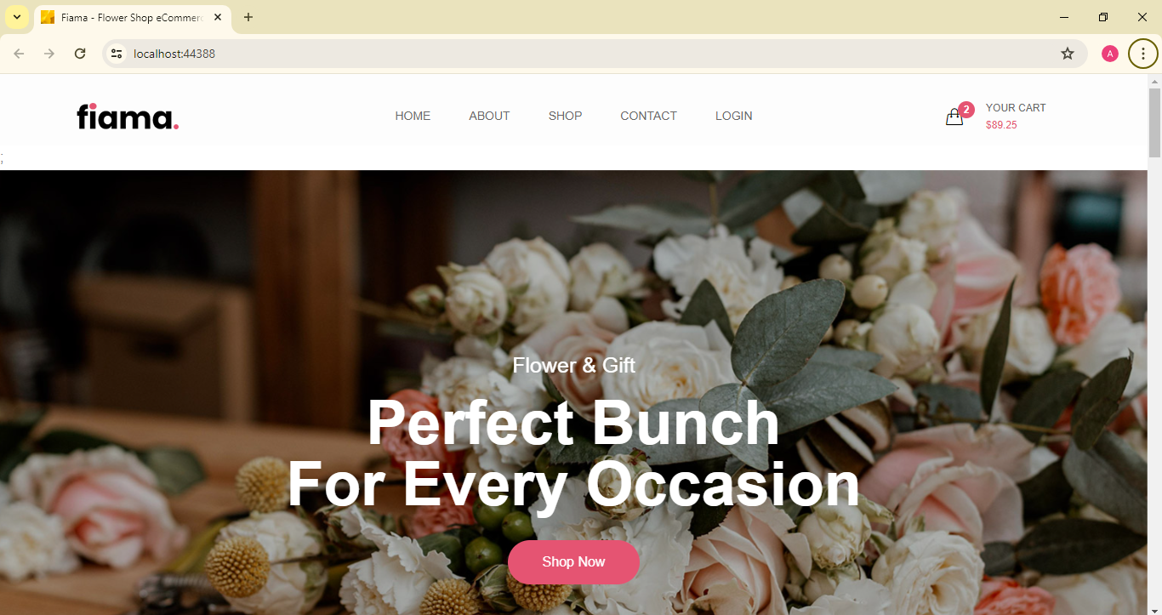

Home-page-2

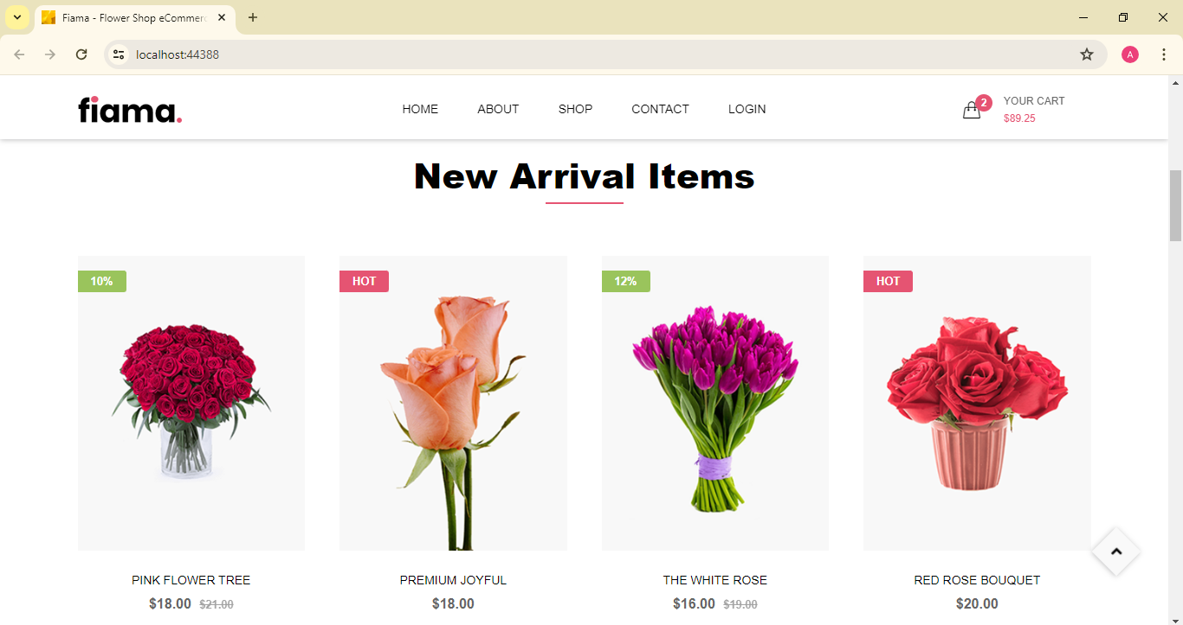

Shop

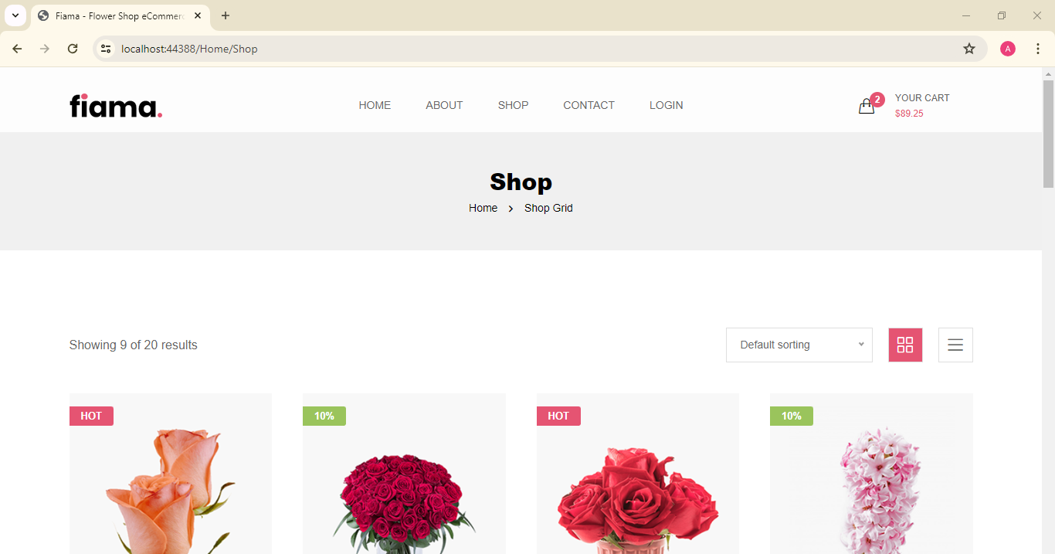

Admin Login

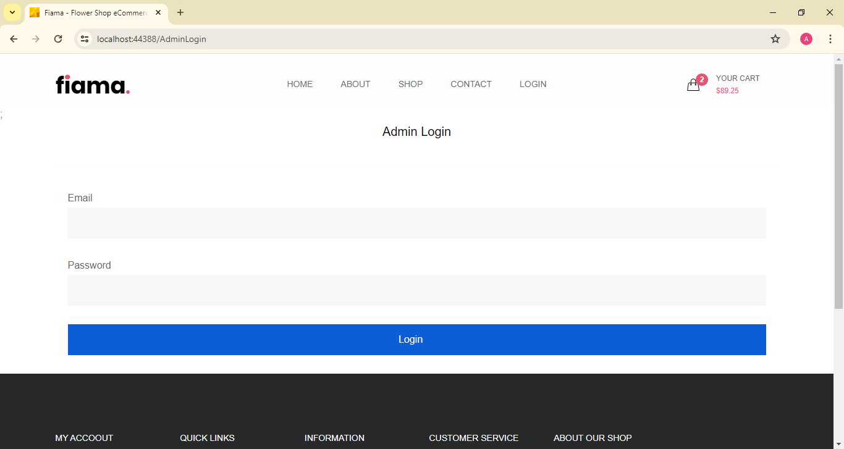

Admin Dashboard

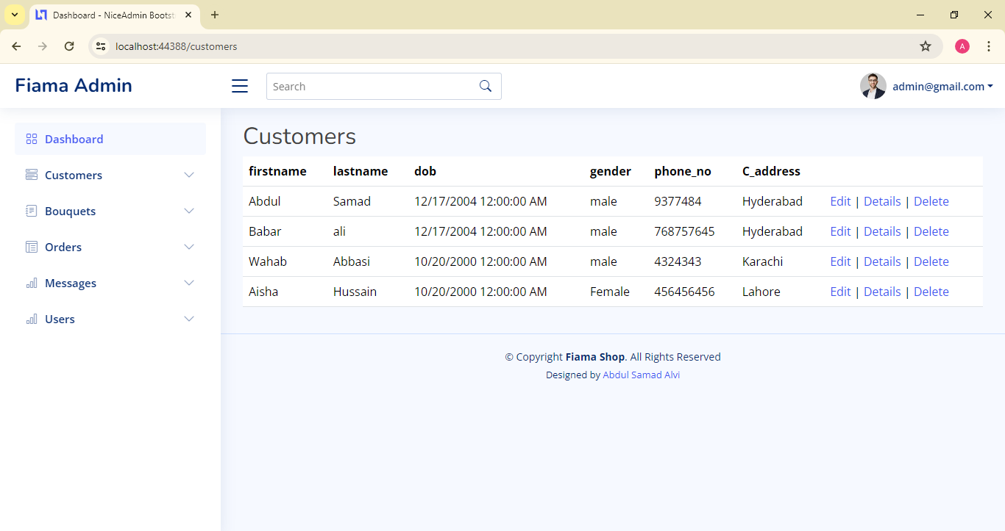

Add Bouquets

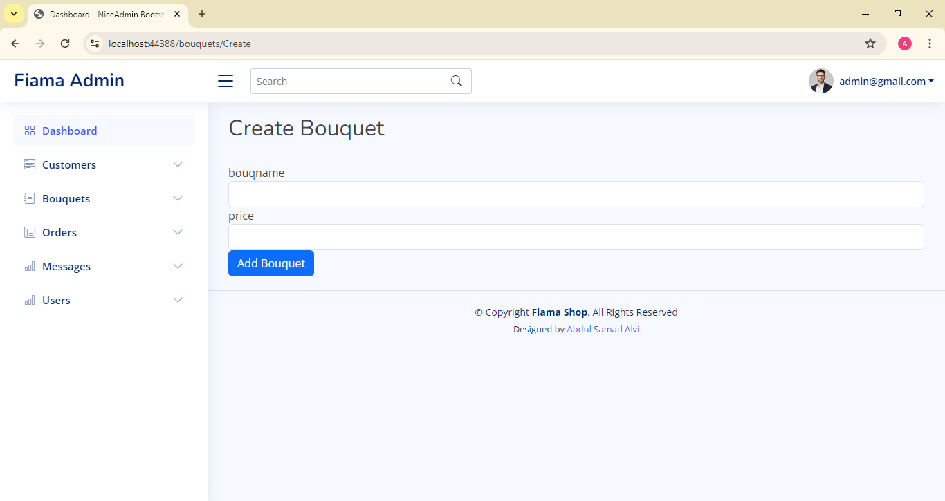

SOURCE CODE

@{

ViewBag.Title = "Home Page";

}

@Html.Raw(TempData["LoginSuccessMessage"]);

<div class="ltn__utilize-overlay"></div>

<!-- SLIDER AREA START (slider-6) -->

<div class="ltn__slider-area ltn__slider-3 ltn__slider-6">

<div class="ltn__slide-two-active slick-slide-arrow-1 slick-slide-dots-1 arrow-white--">

<!-- ltn__slide-item -->

<div class="ltn__slide-item ltn__slide-item-8 ltn__slide-item-9--- text-color-white bg-image bg-overlay-theme-black-10---" data-bs-bg="img/slider/11.jpg">

<div class="ltn__slide-item-inner text-center">

<div class="container">

<div class="row">

<div class="col-lg-12 align-self-center">

<div class="slide-item-info">

<div class="slide-item-info-inner ltn__slide-animation">

<div class="slide-item-info">

<div class="slide-item-info-inner ltn__slide-animation">

<h6 class="slide-sub-title white-color slide-title-line-2--- animated">Flower & Gift</h6>

<h1 class="slide-title white-color animated ">Perfect Bunch <br>For Every Occasion</h1>

<div class="slide-brief animated d-none">

<p>Lorem ipsum dolor sit amet, consectetur adipisicing elit, sed do eiusmod tempor incididunt ut labore.</p>

</div>

<div class="btn-wrapper animated">

@Html.ActionLink("Shop Now", "Shop", "Home", null, new { @class = "theme-btn-1 btn btn-round" })

</div>

</div>

</div>

</div>

</div>

</div>

</div>

</div>

</div>

</div>

<!-- -->

</div>

</div>

<!-- SLIDER AREA END -->

<!-- PRODUCT AREA START -->

<div class="ltn__product-area ltn__product-gutter pt-90 pb-40---">

<div class="container">

<div class="row">

<div class="col-lg-12">

<div class="section-title-area text-center">

<h1 class="section-title section-title-border">New Arrival Items</h1>

</div>

</div>

</div>

<div class="row justify-content-center">

<!-- ltn__product-item -->

<div class="col-lg-3 col-md-4 col-sm-6 col-6">

<div class="ltn__product-item text-center">

<div class="product-img">

<a href="@Url.Action("ProductDetail", "Home")">

<img src="~/img/product/1.png" alt="#" />

</a>

<div class="product-badge">

<ul>

<li class="badge-2">10%</li>

</ul>

</div>

<div class="product-hover-action product-hover-action-2">

<ul>

<li>

<a href="#" title="Quick View" data-bs-toggle="modal" data-bs-target="#quick_view_modal">

<i class="icon-magnifier"></i>

</a>

</li>

<li class="add-to-cart">

<a href="#" title="Add to Cart" data-bs-toggle="modal" data-bs-target="#add_to_cart_modal">

<span class="cart-text d-none d-xl-block">Add to Cart</span>

<span class="d-block d-xl-none"><i class="icon-handbag"></i></span>

</a>

</li>

<li>

<a href="#" title="Quick View" data-bs-toggle="modal" data-bs-target="#quick_view_modal">

<i class="icon-shuffle"></i>

</a>

</li>

</ul>

</div>

</div>

<div class="product-info">

<h2 class="product-title"><a href="@Url.Action("ProductDetail", "Home")">Pink Flower Tree</a></h2>

<div class="product-price">

<span>$18.00</span>

<del>$21.00</del>

</div>

</div>

</div>

</div>

<!-- ltn__product-item -->

<div class="col-lg-3 col-md-4 col-sm-6 col-6">

<div class="ltn__product-item text-center">

<div class="product-img">

<a href="@Url.Action("ProductDetail", "Home")">

<img src="~/img/product/2.png" alt="#" />

</a>

<div class="product-badge">

<ul>

<li class="badge-1">Hot</li>

</ul>

</div>

<div class="product-hover-action product-hover-action-2">

<ul>

<li>

<a href="#" title="Quick View" data-bs-toggle="modal" data-bs-target="#quick_view_modal">

<i class="icon-magnifier"></i>

</a>

</li>

<li class="add-to-cart">

<a href="#" title="Add to Cart" data-bs-toggle="modal" data-bs-target="#add_to_cart_modal">

<span class="cart-text d-none d-xl-block">Add to Cart</span>

<span class="d-block d-xl-none"><i class="icon-handbag"></i></span>

</a>

</li>

<li>

<a href="#" title="Quick View" data-bs-toggle="modal" data-bs-target="#quick_view_modal">

<i class="icon-shuffle"></i>

</a>

</li>

</ul>

</div>

</div>

<div class="product-info">

<h2 class="product-title"><a href="@Url.Action("ProductDetail", "Home")">Premium Joyful</a></h2>

<div class="product-price">

<span>$18.00</span>

</div>

</div>

</div>

</div>

<!-- ltn__product-item -->

<div class="col-lg-3 col-md-4 col-sm-6 col-6">

<div class="ltn__product-item text-center">

<div class="product-img">

<a href="@Url.Action("ProductDetail", "Home")">

<img src="~/img/product/3.png" alt="#" />

</a>

<div class="product-badge">

<ul>

<li class="badge-2">12%</li>

</ul>

</div>

<div class="product-hover-action product-hover-action-2">

<ul>

<li>

<a href="#" title="Quick View" data-bs-toggle="modal" data-bs-target="#quick_view_modal">

<i class="icon-magnifier"></i>

</a>

</li>

<li class="add-to-cart">

<a href="#" title="Add to Cart" data-bs-toggle="modal" data-bs-target="#add_to_cart_modal">

<span class="cart-text d-none d-xl-block">Add to Cart</span>

<span class="d-block d-xl-none"><i class="icon-handbag"></i></span>

</a>

</li>

<li>

<a href="#" title="Quick View" data-bs-toggle="modal" data-bs-target="#quick_view_modal">

<i class="icon-shuffle"></i>

</a>

</li>

</ul>

</div>

</div>

<div class="product-info">

<h2 class="product-title"><a href="@Url.Action("ProductDetail", "Home")">The White Rose</a></h2>

<div class="product-price">

<span>$16.00</span>

<del>$19.00</del>

</div>

</div>

</div>

</div>

<!-- ltn__product-item -->

<div class="col-lg-3 col-md-4 col-sm-6 col-6">

<div class="ltn__product-item text-center">

<div class="product-img">

<a href="@Url.Action("ProductDetail", "Home")">

<img src="~/img/product/4.png" alt="#" />

</a>

<div class="product-badge">

<ul>

<li class="badge-1">Hot</li>

</ul>

</div>

<div class="product-hover-action product-hover-action-2">

<ul>

<li>

<a href="#" title="Quick View" data-bs-toggle="modal" data-bs-target="#quick_view_modal">

<i class="icon-magnifier"></i>

</a>

</li>

<li class="add-to-cart">

<a href="#" title="Add to Cart" data-bs-toggle="modal" data-bs-target="#add_to_cart_modal">

<span class="cart-text d-none d-xl-block">Add to Cart</span>

<span class="d-block d-xl-none"><i class="icon-handbag"></i></span>

</a>

</li>

<li>

<a href="#" title="Quick View" data-bs-toggle="modal" data-bs-target="#quick_view_modal">

<i class="icon-shuffle"></i>

</a>

</li>

</ul>

</div>

</div>

<div class="product-info">

<h2 class="product-title"><a href="@Url.Action("ProductDetail", "Home")">Red Rose Bouquet</a></h2>

<div class="product-price">

<span>$20.00</span>

</div>

</div>

</div>

</div>

<!-- ltn__product-item -->

<div class="col-lg-3 col-md-4 col-sm-6 col-6">

<div class="ltn__product-item text-center">

<div class="product-img">

<a href="@Url.Action("ProductDetail", "Home")">

<img src="~/img/product/5.png" alt="#" />

</a>

<div class="product-badge">

<ul>

<li class="badge-1">Hot</li>

</ul>

</div>

<div class="product-hover-action product-hover-action-2">

<ul>

<li>

<a href="#" title="Quick View" data-bs-toggle="modal" data-bs-target="#quick_view_modal">

<i class="icon-magnifier"></i>

</a>

</li>

<li class="add-to-cart">

<a href="#" title="Add to Cart" data-bs-toggle="modal" data-bs-target="#add_to_cart_modal">

<span class="cart-text d-none d-xl-block">Add to Cart</span>

<span class="d-block d-xl-none"><i class="icon-handbag"></i></span>

</a>

</li>

<li>

<a href="#" title="Quick View" data-bs-toggle="modal" data-bs-target="#quick_view_modal">

<i class="icon-shuffle"></i>

</a>

</li>

</ul>

</div>

</div>

<div class="product-info">

<h2 class="product-title"><a href="@Url.Action("ProductDetail", "Home")">Heart's Desire</a></h2>

<div class="product-price">

<span>$15.00</span>

</div>

</div>

</div>

</div>

<!-- ltn__product-item -->

<div class="col-lg-3 col-md-4 col-sm-6 col-6">

<div class="ltn__product-item text-center">

<div class="product-img">

<a href="@Url.Action("ProductDetail", "Home")">

<img src="~/img/product/6.png" alt="#" />

</a>

<div class="product-badge">

<ul>

<li class="badge-2">15%</li>

</ul>

</div>

<div class="product-hover-action product-hover-action-2">

<ul>

<li>

<a href="#" title="Quick View" data-bs-toggle="modal" data-bs-target="#quick_view_modal">

<i class="icon-magnifier"></i>

</a>

</li>

<li class="add-to-cart">

<a href="#" title="Add to Cart" data-bs-toggle="modal" data-bs-target="#add_to_cart_modal">

<span class="cart-text d-none d-xl-block">Add to Cart</span>

<span class="d-block d-xl-none"><i class="icon-handbag"></i></span>

</a>

</li>

<li>

<a href="#" title="Quick View" data-bs-toggle="modal" data-bs-target="#quick_view_modal">

<i class="icon-shuffle"></i>

</a>

</li>

</ul>

</div>

<div class="ltn__product-countdown">

<div class="ltn__countdown" data-countdown="2021/09/25"></div>

</div>

</div>

<div class="product-info">

<h2 class="product-title"><a href="@Url.Action("ProductDetail", "Home")">Assorted Roses</a></h2>

<div class="product-price">

<span>$17.00</span>

</div>

</div>

</div>

</div>

<!-- ltn__product-item -->

<div class="col-lg-3 col-md-4 col-sm-6 col-6">

<div class="ltn__product-item text-center">

<div class="product-img">

<a href="@Url.Action("ProductDetail", "Home")">

<img src="~/img/product/7.png" alt="#" />

</a>

<div class="product-badge">

<ul>

<li class="badge-1">Hot</li>

</ul>

</div>

<div class="product-hover-action product-hover-action-2">

<ul>

<li>

<a href="#" title="Quick View" data-bs-toggle="modal" data-bs-target="#quick_view_modal">

<i class="icon-magnifier"></i>

</a>

</li>

<li class="add-to-cart">

<a href="#" title="Add to Cart" data-bs-toggle="modal" data-bs-target="#add_to_cart_modal">

<span class="cart-text d-none d-xl-block">Add to Cart</span>

<span class="d-block d-xl-none"><i class="icon-handbag"></i></span>

</a>

</li>

<li>

<a href="#" title="Quick View" data-bs-toggle="modal" data-bs-target="#quick_view_modal">

<i class="icon-shuffle"></i>

</a>

</li>

</ul>

</div>

</div>

<div class="product-info">

<h2 class="product-title"><a href="@Url.Action("ProductDetail", "Home")">Roses Surprise</a></h2>

<div class="product-price">

<span>$12.00</span>

</div>

</div>

</div>

</div>

<!-- ltn__product-item -->

<div class="col-lg-3 col-md-4 col-sm-6 col-6">

<div class="ltn__product-item text-center">

<div class="product-img">

<a href="@Url.Action("ProductDetail", "Home")">

<img src="~/img/product/8.png" alt="#" />

</a>

<div class="product-badge">

<ul>

<li class="badge-1">12%</li>

</ul>

</div>

<div class="product-hover-action product-hover-action-2">

<ul>

<li>

<a href="#" title="Quick View" data-bs-toggle="modal" data-bs-target="#quick_view_modal">

<i class="icon-magnifier"></i>

</a>

</li>

<li class="add-to-cart">

<a href="#" title="Add to Cart" data-bs-toggle="modal" data-bs-target="#add_to_cart_modal">

<span class="cart-text d-none d-xl-block">Add to Cart</span>

<span class="d-block d-xl-none"><i class="icon-handbag"></i></span>

</a>

</li>

<li>

<a href="#" title="Quick View" data-bs-toggle="modal" data-bs-target="#quick_view_modal">

<i class="icon-shuffle"></i>

</a>

</li>

</ul>

</div>

</div>

<div class="product-info">

<h2 class="product-title"><a href="@Url.Action("ProductDetail", "Home")">Tropical Peace Lily</a></h2>

<div class="product-price">

<span>$14</span>

<del>$25.00</del>

</div>

</div>

</div>

</div>

</div>

</div>

</div>

<!-- PRODUCT SLIDER AREA END -->

<!-- BANNER AREA START -->

<div class="ltn__banner-area mt-40">

<div class="container">

<div class="row">

<div class="col-lg-4 col-sm-6">

<div class="ltn__banner-item">

<div class="ltn__banner-img">

<a href="@Url.Action("Shop", "Home")">

<img src="img/banner/4.jpg" alt="Banner Image">

</a>

</div>

</div>

</div>

<div class="col-lg-4 col-sm-6">

<div class="ltn__banner-item">

<div class="ltn__banner-img">

<a href="@Url.Action("Shop", "Home")">

<img src="img/banner/2.jpg" alt="Banner Image">

</a>

</div>

</div>

</div>

<div class="col-lg-4 col-sm-6">

<div class="ltn__banner-item">

<div class="ltn__banner-img">

<a href="@Url.Action("Shop", "Home")">

<img src="img/banner/5.jpg" alt="Banner Image">

</a>

</div>

</div>

</div>

</div>

</div>

</div>

<!-- BANNER AREA END -->

<!-- COUNTDOWN AREA START -->

<div class="ltn__countdown-area section-bg-1 bg-image-right mt-70" data-bs-bg="img/bg/2.jpg">

<div class="container">

<div class="row">

<div class="col-lg-6 align-self-center">

<div class="ltn__countdown-info ltn__countdown-4-info text-center--- pt-100 pb-100">

<div class="section-title-area ltn__section-title-2--- mb-0---">

<h6 class="ltn__secondary-color">Deal of the day</h6>

<!-- <h1 class="section-title">Hot Deal ! Sale Up To <span>25% Off</span></h1> -->

<h1 class="section-title">

Shop Your Wedding Flowers <br>

Best Offer- $12</span>

</h1>

</div>

<div class="ltn__countdown ltn__countdown-4 mb-15" data-countdown="2025/09/25"></div>

<div class="btn-wrapper animated">

@Html.ActionLink("Shop Now", "Shop", "Home", null, new { @class = "theme-btn-2 btn btn-round" })

</div>

<div class="countdown-img d-none d-xl-block">

<img src="img/bg/3.png" alt="#">

</div>

</div>

</div>

</div>

</div>

</div>

<!-- COUNTDOWN AREA END -->

<!-- PRODUCT SLIDER AREA START -->

<div class="ltn__product-slider-area ltn__product-gutter pt-90 pb-40">

<div class="container">

<div class="row">

<div class="col-lg-12">

<div class="section-title-area text-center">

<h1 class="section-title section-title-border">Gift - New Baby - Thanks</h1>

</div>

</div>

</div>

<div class="row ltn__product-slider-item-four-active slick-arrow-1">

<!-- ltn__product-item -->

<div class="col-12">

<div class="ltn__product-item text-center">

<div class="product-img">

<a href="@Url.Action("ProductDetail", "Home")">

<img src="~/img/product/1.png" alt="#" />

</a>

<div class="product-badge">

<ul>

<li class="badge-2">10%</li>

</ul>

</div>

<div class="product-hover-action product-hover-action-2">

<ul>

<li>

<a href="#" title="Quick View" data-bs-toggle="modal" data-bs-target="#quick_view_modal">

<i class="icon-magnifier"></i>

</a>

</li>

<li class="add-to-cart">

<a href="#" title="Add to Cart" data-bs-toggle="modal" data-bs-target="#add_to_cart_modal">

<span class="cart-text d-none d-xl-block">Add to Cart</span>

<span class="d-block d-xl-none"><i class="icon-handbag"></i></span>

</a>

</li>

<li>

<a href="#" title="Quick View" data-bs-toggle="modal" data-bs-target="#quick_view_modal">

<i class="icon-shuffle"></i>

</a>

</li>

</ul>

</div>

</div>

<div class="product-info">

<h2 class="product-title"><a href="@Url.Action("ProductDetail", "Home")">Pink Flower Tree</a></h2>

<div class="product-price">

<span>$18.00</span>

<del>$21.00</del>

</div>

</div>

</div>

</div>

<!-- ltn__product-item -->

<div class="col-12">

<div class="ltn__product-item text-center">

<div class="product-img">

<a href="@Url.Action("ProductDetail", "Home")">

<img src="~/img/product/2.png" alt="#" />

</a>

<div class="product-badge">

<ul>

<li class="badge-1">Hot</li>

</ul>

</div>

<div class="product-hover-action product-hover-action-2">

<ul>

<li>

<a href="#" title="Quick View" data-bs-toggle="modal" data-bs-target="#quick_view_modal">

<i class="icon-magnifier"></i>

</a>

</li>

<li class="add-to-cart">

<a href="#" title="Add to Cart" data-bs-toggle="modal" data-bs-target="#add_to_cart_modal">

<span class="cart-text d-none d-xl-block">Add to Cart</span>

<span class="d-block d-xl-none"><i class="icon-handbag"></i></span>

</a>

</li>

<li>

<a href="#" title="Quick View" data-bs-toggle="modal" data-bs-target="#quick_view_modal">

<i class="icon-shuffle"></i>

</a>

</li>

</ul>

</div>

</div>

<div class="product-info">

<h2 class="product-title"><a href="@Url.Action("ProductDetail", "Home")">Premium Joyful</a></h2>

<div class="product-price">

<span>$18.00</span>

</div>

</div>

</div>

</div>

<!-- ltn__product-item -->

<div class="col-12">

<div class="ltn__product-item text-center">

<div class="product-img">

<a href="@Url.Action("ProductDetail", "Home")">

<img src="~/img/product/3.png" alt="#" />

</a>

<div class="product-badge">

<ul>

<li class="badge-2">12%</li>

</ul>

</div>

<div class="product-hover-action product-hover-action-2">

<ul>

<li>

<a href="#" title="Quick View" data-bs-toggle="modal" data-bs-target="#quick_view_modal">

<i class="icon-magnifier"></i>

</a>

</li>

<li class="add-to-cart">

<a href="#" title="Add to Cart" data-bs-toggle="modal" data-bs-target="#add_to_cart_modal">

<span class="cart-text d-none d-xl-block">Add to Cart</span>

<span class="d-block d-xl-none"><i class="icon-handbag"></i></span>

</a>

</li>

<li>

<a href="#" title="Quick View" data-bs-toggle="modal" data-bs-target="#quick_view_modal">

<i class="icon-shuffle"></i>

</a>

</li>

</ul>

</div>

</div>

<div class="product-info">

<h2 class="product-title"><a href="@Url.Action("ProductDetail", "Home")">The White Rose</a></h2>

<div class="product-price">

<span>$16.00</span>

<del>$19.00</del>

</div>

</div>

</div>

</div>

<!-- ltn__product-item -->

<div class="col-12">

<div class="ltn__product-item text-center">

<div class="product-img">

<a href="@Url.Action("ProductDetail", "Home")">

<img src="~/img/product/4.png" alt="#" />

</a>

<div class="product-badge">

<ul>

<li class="badge-1">Hot</li>

</ul>

</div>

<div class="product-hover-action product-hover-action-2">

<ul>

<li>

<a href="#" title="Quick View" data-bs-toggle="modal" data-bs-target="#quick_view_modal">

<i class="icon-magnifier"></i>

</a>

</li>

<li class="add-to-cart">

<a href="#" title="Add to Cart" data-bs-toggle="modal" data-bs-target="#add_to_cart_modal">

<span class="cart-text d-none d-xl-block">Add to Cart</span>

<span class="d-block d-xl-none"><i class="icon-handbag"></i></span>

</a>

</li>

<li>

<a href="#" title="Quick View" data-bs-toggle="modal" data-bs-target="#quick_view_modal">

<i class="icon-shuffle"></i>

</a>

</li>

</ul>

</div>

</div>

<div class="product-info">

<h2 class="product-title"><a href="@Url.Action("ProductDetail", "Home")">Red Rose Bouquet</a></h2>

<div class="product-price">

<span>$20.00</span>

</div>

</div>

</div>

</div>

<!-- ltn__product-item -->

<div class="col-12">

<div class="ltn__product-item text-center">

<div class="product-img">

<a href="@Url.Action("ProductDetail", "Home")">

<img src="~/img/product/5.png" alt="#" />

</a>

<div class="product-badge">

<ul>

<li class="badge-1">Hot</li>

</ul>

</div>

<div class="product-hover-action product-hover-action-2">

<ul>

<li>

<a href="#" title="Quick View" data-bs-toggle="modal" data-bs-target="#quick_view_modal">

<i class="icon-magnifier"></i>

</a>

</li>

<li class="add-to-cart">

<a href="#" title="Add to Cart" data-bs-toggle="modal" data-bs-target="#add_to_cart_modal">

<span class="cart-text d-none d-xl-block">Add to Cart</span>

<span class="d-block d-xl-none"><i class="icon-handbag"></i></span>

</a>

</li>

<li>

<a href="#" title="Quick View" data-bs-toggle="modal" data-bs-target="#quick_view_modal">

<i class="icon-shuffle"></i>

</a>

</li>

</ul>

</div>

</div>

<div class="product-info">

<h2 class="product-title"><a href="@Url.Action("ProductDetail", "Home")">Heart's Desire</a></h2>

<div class="product-price">

<span>$15.00</span>

</div>

</div>

</div>

</div>

</div>

</div>

</div>

<!-- PRODUCT SLIDER AREA END -->

<!-- FEATURE AREA START ( Feature - 3) -->

<div class="ltn__feature-area mb-90">

<div class="container">

<div class="row">

<div class="col-lg-12">

<div class="ltn__feature-item-box-wrap ltn__feature-item-box-wrap-2 ltn__border section-bg-6">

<div class="ltn__feature-item ltn__feature-item-8">

<div class="ltn__feature-icon">

<img src="img/icons/svg/8-trolley.svg" alt="#">

</div>

<div class="ltn__feature-info">

<h4>Free shipping</h4>

<p>On all orders over $49.00</p>

</div>

</div>

<div class="ltn__feature-item ltn__feature-item-8">

<div class="ltn__feature-icon">

<img src="img/icons/svg/9-money.svg" alt="#">

</div>

<div class="ltn__feature-info">

<h4>15 days returns</h4>

<p>Moneyback guarantee</p>

</div>

</div>

<div class="ltn__feature-item ltn__feature-item-8">

<div class="ltn__feature-icon">

<img src="img/icons/svg/10-credit-card.svg" alt="#">

</div>

<div class="ltn__feature-info">

<h4>Secure checkout</h4>

<p>Protected by Paypal</p>

</div>

</div>

<div class="ltn__feature-item ltn__feature-item-8">

<div class="ltn__feature-icon">

<img src="img/icons/svg/11-gift-card.svg" alt="#">

</div>

<div class="ltn__feature-info">

<h4>Offer & gift here</h4>

<p>On all orders over</p>

</div>

</div>

</div>

</div>

</div>

</div>

</div>

<!-- FEATURE AREA END -->

<!-- NEWSLETTER AREA START -->

<div class="ltn__newsletter-area section-bg-1 bg-overlay-black-10 bg-image pt-110 pb-90" data-bs-bg="img/bg/3.jpg">

<div class="container">

<div class="row">

<div class="col-lg-8 offset-lg-2">

<div class="ltn__newsletter-inner ltn__newsletter-inner-4 text-color-white text-center">

<h1>Get The Latest Deals</h1>

<h5>$30 coupon for first shopping</h5>

<form action="#" class="ltn__form-box">

<input type="email" name="email" placeholder="Email*">

<div class="btn-wrapper">

<button class="theme-btn-1 btn text-uppercase" type="submit">Subscribe</button>

</div>

</form>

</div>

</div>

</div>

</div>

</div>

<!-- NEWSLETTER AREA END -->

Thank You So Much